Python Programming for Data Handling Practical File

Name: ANSH RAJ

Examination Roll No.: 22003582112

Roll No.: 22/25081

Semester: III

1. Write a Python program to calculate the factorial of a number.

def factorial(n):

if n == 0 or n == 1:

return 1

else:

return n * factorial(n - 1)

# Get user input

num = int(input("Enter a number: "))

# Check if the number is negative

if num < 0:

print("Factorial is not defined for negative numbers.")

else:

result = factorial(num)

print(f"The factorial of {num} is: {result}")

output:-

Enter a number: 5

The factorial of 5 is: 120

2. Write a Python program to generate prime numbers between 1 to n, where n is provided as input by the user.

def is_prime(num):

if num < 2:

return False

for i in range(2, int(num**0.5) + 1):

if num % i == 0:

return False

return True

def generate_primes(n):

primes = [num for num in range(2, n+1) if is_prime(num)]

return primes

n = int(input("Enter a value of n: "))

if n < 0:

print("Please enter a non-negative number.")

else:

prime_numbers = generate_primes(n)

print(f"Prime numbers between 1 and {n}: {prime_numbers}")

output:-

Enter a value of n: 19

Prime numbers between 1 and 19: [2, 3, 5, 7, 11, 13, 17, 19]

3. Write a Python program to find the sum and average of numbers in a given list.

def calculate_sum_and_average(numbers):

total = sum(numbers)

average = total / len(numbers) if len(numbers) > 0 else 0

return total, average

input_numbers = input("Enter a list of numbers separated by spaces: ")

numbers = [float(x) for x in input_numbers.split() if x.replace(".", "", 1).isdigit()]

if not numbers:

print("Please enter at least one valid number.")

else:

sum_result, average_result = calculate_sum_and_average(numbers)

print(f"Sum: {sum_result}")

print(f"Average: {average_result}")

output:-

Enter a list of numbers separated by spaces: 4 6 7 3 5

Sum: 25.0

Average: 5.0

4) Given two sets, set1 and set2, write a Python program to find their union, intersection, and difference.

set1 = {1, 2, 3, 4, 5}

set2 = {3, 4, 5, 6, 7}

union_set = set1.union(set2)

print(f"Union of set1 and set2: {union_set}")

intersection_set = set1.intersection(set2)

print(f"Intersection of set1 and set2: {intersection_set}")

difference_set1 = set1.difference(set2)

print(f"Difference of set1 and set2: {difference_set1}")

difference_set2 = set2.difference(set1)

print(f"Difference of set2 and set1: {difference_set2}")

output:-

Union of set1 and set2: {1, 2, 3, 4, 5, 6, 7}

Intersection of set1 and set2: {3, 4, 5}

Difference of set1 and set2: {1, 2}

Difference of set2 and set1: {6, 7}

5) Given a list of numbers, write a Python program to count the number of times an element occurs in a list and create a dictionary with element:count as key:value pairs.

def count_elements(lst):

element_count_dict = {}

for element in lst:

if element in element_count_dict:

element_count_dict[element] += 1

else:

element_count_dict[element] = 1

return element_count_dict

numbers_list = [1, 2, 3, 1, 2, 4, 1, 3, 5]

element_count_dictionary = count_elements(numbers_list)

print("Original List:", numbers_list)

print("Element Count Dictionary:", element_count_dictionary)

output:-

Original List: [1, 2, 3, 1, 2, 4, 1, 3, 5]

Element Count Dictionary: {1: 3, 2: 2, 3: 2, 4: 1, 5: 1}

6) Write a Python program to swap the first two and last two characters of a given string.

def swap_first_and_last_two_chars(input_str):

if len(input_str) < 2:

return input_str

first_two_chars = input_str[:2]

last_two_chars = input_str[-2:]

middle_chars = input_str[2:-2]

swapped_str = last_two_chars + middle_chars + first_two_chars

return swapped_str

input_string = input("Enter a string: ")

result_string = swap_first_and_last_two_chars(input_string)

print("Original String:", input_string)

print("Swapped String:", result_string)

output:-

Enter a string: python language

Original String: python language

Swapped String: gethon languapy

7) Write a Python program to create a text file having names of ten Indian cities.

cities = ["Mumbai", "Delhi", "Bangalore", "Hyderabad", "Chennai", "Kolkata", "Ahmedabad", "Pune", "Jaipur", "Lucknow"]

file_name = "indian_cities.txt"

with open(file_name, 'w') as file:

for city in cities:

file.write(city + '\n')

print(f"The file '{file_name}' has been created with the names of ten Indian cities.")

output:-

The file 'indian_cities.txt' has been created with the names of ten Indian cities.

8) Write a Python program to create a text file having atleast five lines about your college using

writelines() function.

file_name = "college_description.txt"

college_description = [

"Welcome to ARSD College!",

" ARSD College is known for its outstanding academic programs.",

"Our campus is equipped with state-of-the-art facilities and a vibrant student community.",

"Dedicated faculty members strive for excellence in teaching and research.",

"Join us at ARSD College and embark on a journey of knowledge and personal growth."

]

with open(file_name, 'w') as file:

file.writelines(line + '\n' for line in college_description)

print(f"The file '{file_name}' has been created with a description of the college.")

output:-

The file 'college_description.txt' has been created with a description of the college.

9) Write a Python program which reads the data from three input files having Employee Names and merges them into one output file.

input_files = ["input1.txt", "input2.txt", "input3.txt"]

output_file = "merged_output.txt"

def merge_files(input_files, output_file):

with open(output_file, 'w') as output:

for input_file in input_files:

with open(input_file, 'r') as input_data:

output.write(input_data.read())

output.write('\n') # Add a newline between data from different files

merge_files(input_files, output_file)

print(f"The data from {len(input_files)} input files has been merged into '{output_file}'.")

output:-

The data from 3 input files has been merged into 'merged_output.txt'.

10) Write a Python program to count the number of vowels in a file and write the vowel: count in a dictionary.

def count_vowels(file_path):

vowels = "aeiouAEIOU"

vowel_count = {vowel: 0 for vowel in vowels}

try:

with open(file_path, 'r') as file:

content = file.read()

for char in content:

if char in vowels:

vowel_count[char] += 1

except FileNotFoundError:

print(f"File '{file_path}' not found.")

return None

return vowel_count

file_path = "vowel.txt"

vowel_count_dict = count_vowels(file_path)

if vowel_count_dict is not None:

print("Vowel Count Dictionary:")

for vowel, count in vowel_count_dict.items():

print(f"{vowel}: {count}")

output:-

Vowel Count Dictionary:

a: 8

e: 2

i: 0

o: 2

u: 0

A: 1

E: 0

I: 1

O: 0

U: 0

11) Write a Python program to create a CSV file having student data: Roll_No, Enrollment No, Name,Course, Semester.

import csv

students_data = [

{"Roll_No": 101, "Enrollment_No": "EN12345", "Name": "John Doe", "Course": "Computer Science", "Semester": 3},

{"Roll_No": 102, "Enrollment_No": "EN67890", "Name": "Jane Smith", "Course": "Electrical Engineering", "Semester": 2},

{"Roll_No": 103, "Enrollment_No": "EN54321", "Name": "Alice Johnson", "Course": "Mechanical Engineering", "Semester": 4},

{"Roll_No": 104, "Enrollment_No": "EN98765", "Name": "Bob Williams", "Course": "Civil Engineering", "Semester": 1},

]

csv_file_name = "student_data.csv"

with open(csv_file_name, mode='w', newline='') as csv_file:

fieldnames = ["Roll_No", "Enrollment_No", "Name", "Course", "Semester"]

writer = csv.DictWriter(csv_file, fieldnames=fieldnames)

writer.writeheader()

writer.writerows(students_data)

print(f"The CSV file '{csv_file_name}' has been created with student data.")

output:-

The CSV file 'student_data.csv' has been created with student data.

12) Write a Python program library to read the CSV file created in the above program and filter out records of II semester students.

import csv

def filter_semester_records(csv_file_path, target_semester):

filtered_records = []

with open(csv_file_path, 'r') as csv_file:

reader = csv.DictReader(csv_file)

for row in reader:

if int(row["Semester"]) == target_semester:

filtered_records.append(row)

return filtered_records

csv_file_path = "student_data.csv"

target_semester = 2

filtered_records = filter_semester_records(csv_file_path, target_semester)

if filtered_records:

print(f"Records for {target_semester} semester:")

for record in filtered_records:

print(record)

else:

print(f"No records found for {target_semester} semester.")

output:-

Records for 2 semester:

{'Roll_No': '102', 'Enrollment_No': 'EN67890', 'Name': 'Jane Smith', 'Course': 'Electrical Engineering', 'Semester': '2'}

13. Write a Python program using tkinter library to create a GUI to enter registration details for an event.

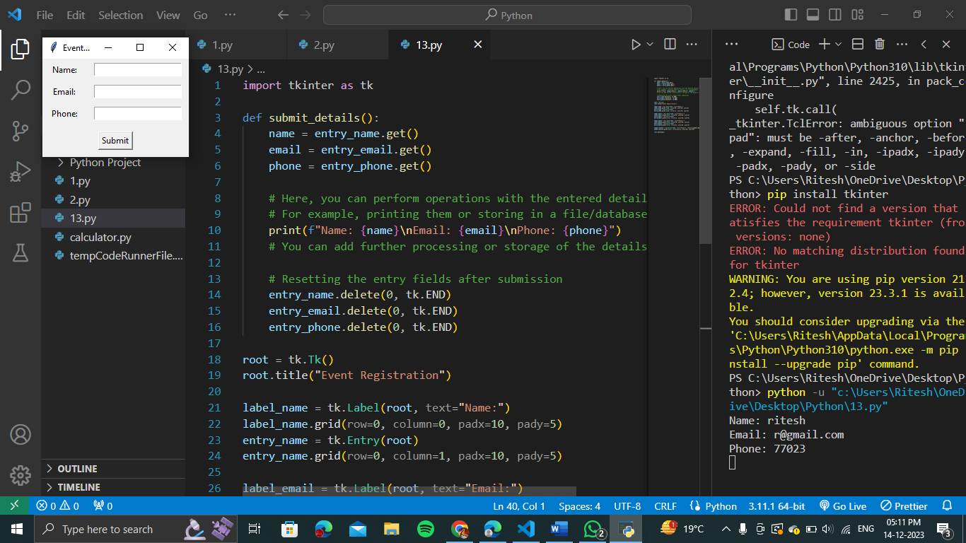

14. Write a Python program using tkinter library to create a calculator to perform addition, subtraction, multiplication and division of two numbers entered by the user.

import tkinter as tk

def calculate():

    try:

        num1 = float(entry_num1.get())

        num2 = float(entry_num2.get())

        operation = operation_var.get()

        if operation == "Addition":

            result = num1 + num2

        elif operation == "Subtraction":

            result = num1 - num2

        elif operation == "Multiplication":

            result = num1 * num2

        elif operation == "Division":

            if num2 == 0:

                result = "Cannot divide by zero"

            else:

                result = num1 / num2

        else:

            result = "Invalid operation"

        result_label.config(text="Result: " + str(result))

    except ValueError:

        result_label.config(text="Please enter valid numbers")

root = tk.Tk()

root.title("Simple Calculator")

label_num1 = tk.Label(root, text="Enter number 1:")

label_num1.grid(row=0, column=0, padx=10, pady=5)

entry_num1 = tk.Entry(root)

entry_num1.grid(row=0, column=1, padx=10, pady=5)

label_num2 = tk.Label(root, text="Enter number 2:")

label_num2.grid(row=1, column=0, padx=10, pady=5)

entry_num2 = tk.Entry(root)

entry_num2.grid(row=1, column=1, padx=10, pady=5)

operation_var = tk.StringVar()

operation_var.set("Addition")

operation_label = tk.Label(root, text="Choose operation:")

operation_label.grid(row=2, column=0, padx=10, pady=5)

operation_menu = tk.OptionMenu(root, operation_var, "Addition", "Subtraction", "Multiplication", "Division")

operation_menu.grid(row=2, column=1, padx=10, pady=5)

calculate_button = tk.Button(root, text="Calculate", command=calculate)

calculate_button.grid(row=3, columnspan=2, padx=10, pady=10)

result_label = tk.Label(root, text="Result: ")

result_label.grid(row=4, columnspan=2, padx=10, pady=5)

root.mainloop()

15. Write a Python program using tkinter library to create an age calculator to calculate age when DOB is entered.

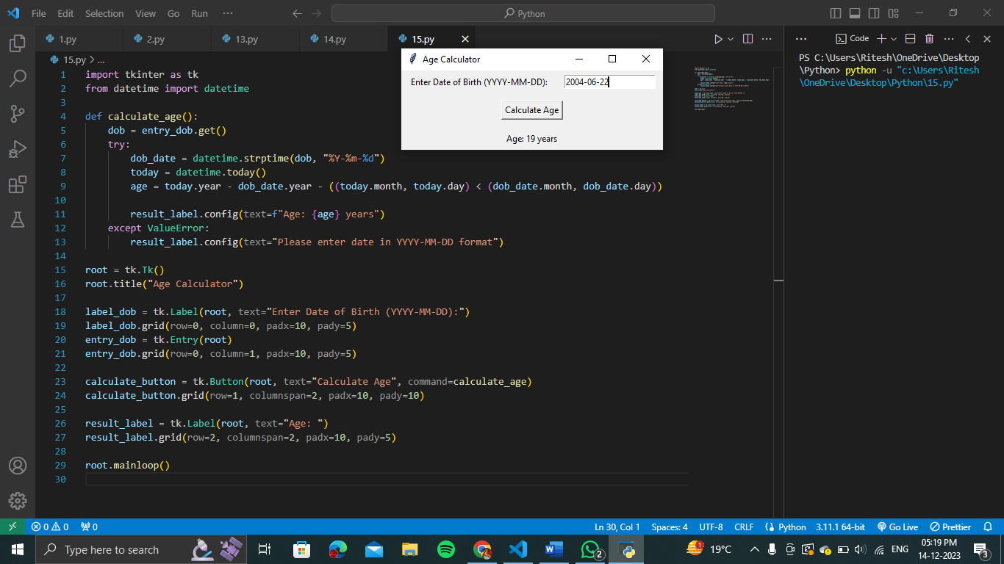

16. Write a Python program using tkinter library to read and write student details namely Roll_No, Enrollment_No, Name, course, Semester through a form and write the entered details to a CSV file.

import tkinter as tk

import csv

# Define student details

fields = ["Roll_No", "Enrollment_No", "Name", "Course", "Semester"]

# Function to read data from CSV file

def read_data():

# Open file in read mode

with open("students.csv", "r") as csvfile:

reader = csv.reader(csvfile)

# Skip header (first line)

next(reader)

# Store data in a list of dictionaries

data = [dict(zip(fields, row)) for row in reader]

return data

# Function to write data to CSV file

def write_data(data):

# Open file in write mode

with open("students.csv", "w", newline="") as csvfile:

writer = csv.DictWriter(csvfile, fieldnames=fields)

# Write header row

writer.writeheader()

# Write data rows

for student in data:

writer.writerow(student)

# Function to handle form submission

def submit_click():

# Get data from entry fields

data = {}

for field, entry in entries.items():

data[field] = entry.get()

# Read existing data from CSV

existing_data = read_data()

# Update data (add new entry)

existing_data.append(data)

# Write updated data to CSV

write_data(existing_data)

# Reset form

for entry in entries.values():

entry.delete(0, tk.END)

# Show success message

success_label.config(text="Student details saved successfully!")

# Initialize main window

root = tk.Tk()

root.title("Student Registration")

# Create frame for form

frame = tk.Frame(root)

frame.pack(pad=10)

# Create labels and entry fields for each detail

entries = {}

for field in fields:

field_label = tk.Label(frame, text=field)

field_label.pack(pady=5)

field_entry = tk.Entry(frame)

entries[field] = field_entry

field_entry.pack()

# Create button to submit form

submit_button = tk.Button(frame, text="Submit", command=submit_click)

submit_button.pack(pady=10)

# Create label to show success message

success_label = tk.Label(frame, text="")

success_label.pack(pady=5)

# Start the main loop

root.mainloop()